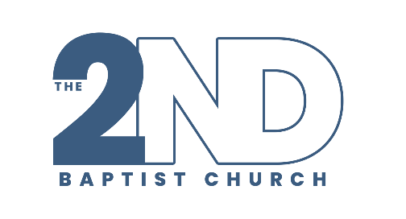
Second Baptist Church
1709 Barrow Road, LR. AR 72204
Dr. Maurice Watson, Senior Pastor
Speaker: Dr. Carla Morris
March 25, 2026
Living By The Book — Aligning Life With God’s Word
Wednesday Night Bible Study Outline
Key Scriptures
Matthew 4:4 Colossians 3:16 Luke 6:46–49
1. What Does It Mean to Live By The Book?
- Life is sustained by God’s Word
- The Word is essential—not optional
Living By The Book Means:
- God’s Word is my standard
- God’s Word is my source
- God’s Word is my strategy
Notes:
2. The Authority of God’s Word
- The Word must dwell in us (live in us)
- It should guide decisions, not just inform them Key Truth:
• If the Word is not leading me... something else is

Notes:

3. Alignment — Bringing Life Into Agreement
• Alignment = my life agrees with God Alignment Shows Up In:
- My decisions
- My behavior
- My lifestyle
Luke 6:46–49
- Hearing AND doing = strong foundation
- Hearing WITHOUT doing = weak foundation Key Truth:
• Storms reveal my foundation Notes:
4. How Do I Live It Daily? 1. Read the Word consistently
Joshua 1:8
2. Meditate on the Word intentionally
Psalm 1:2–3
3. Obey the Word immediately
James 1:22
Key Truth:
• Delayed obedience is still disobedience
Notes:

5. Personal Reflection
- Where is my life out of alignment?
- What have I been hearing but not doing?
- What will I change starting today?
My Response:

